by

use it up: hashtag mini quilt
by Jo Thomas
Uses all 42 squares of a mini charm!
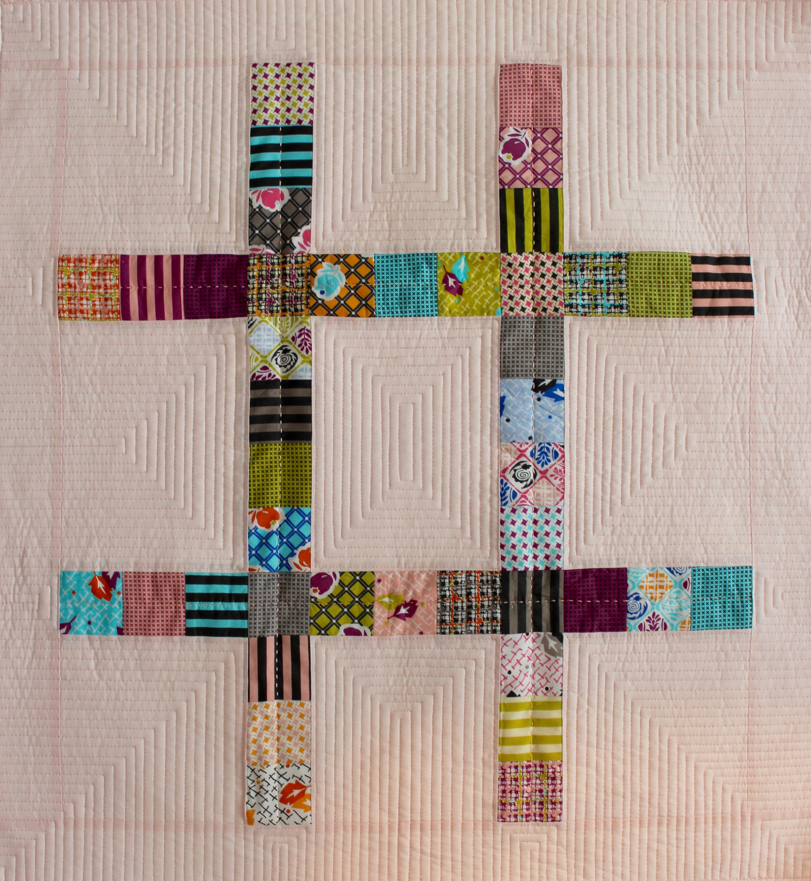
finished size
26 1/2” x 28 1/2”

quilt options: Repeat this block to make a larger quilt! Without the borders, the block’s unfinished size is 24 1/2” x 26 1/2”.

quilt size | block layout (no sashing) | dimensions
baby | 2 x 2 | 48 1/2” x 52 1/2”
youth/  throw | 3 x 3 | 72 1/2” x 78 1/2”
queen | 4 x 4 | 96 1/2” x 104 1/2”

materials
- 1 mini charm pack or 42, 2-1/2” squares
- 1 yard fabric for background & binding
- 1 yard fabric for backing
- 30” x 32” piece batting

cut
From the background fabric:
Cut 2, 6-1/2” x WOF (width of fabric) strips. Subcut into 6, 6-1/2” squares and 3, 6-1/2” x 8-1/2” rectangles.
Cut 4, 2-1/2” x WOF strips. Subcut 2, 2-1/2” x 24-1/2” strips for side borders and 2, 2-1/2” x 26-1/2” strips for top and bottom borders.
Cut 3 binding strips of your preferred width (2” wide for machine binding using 1/4” seam allowance).

sew
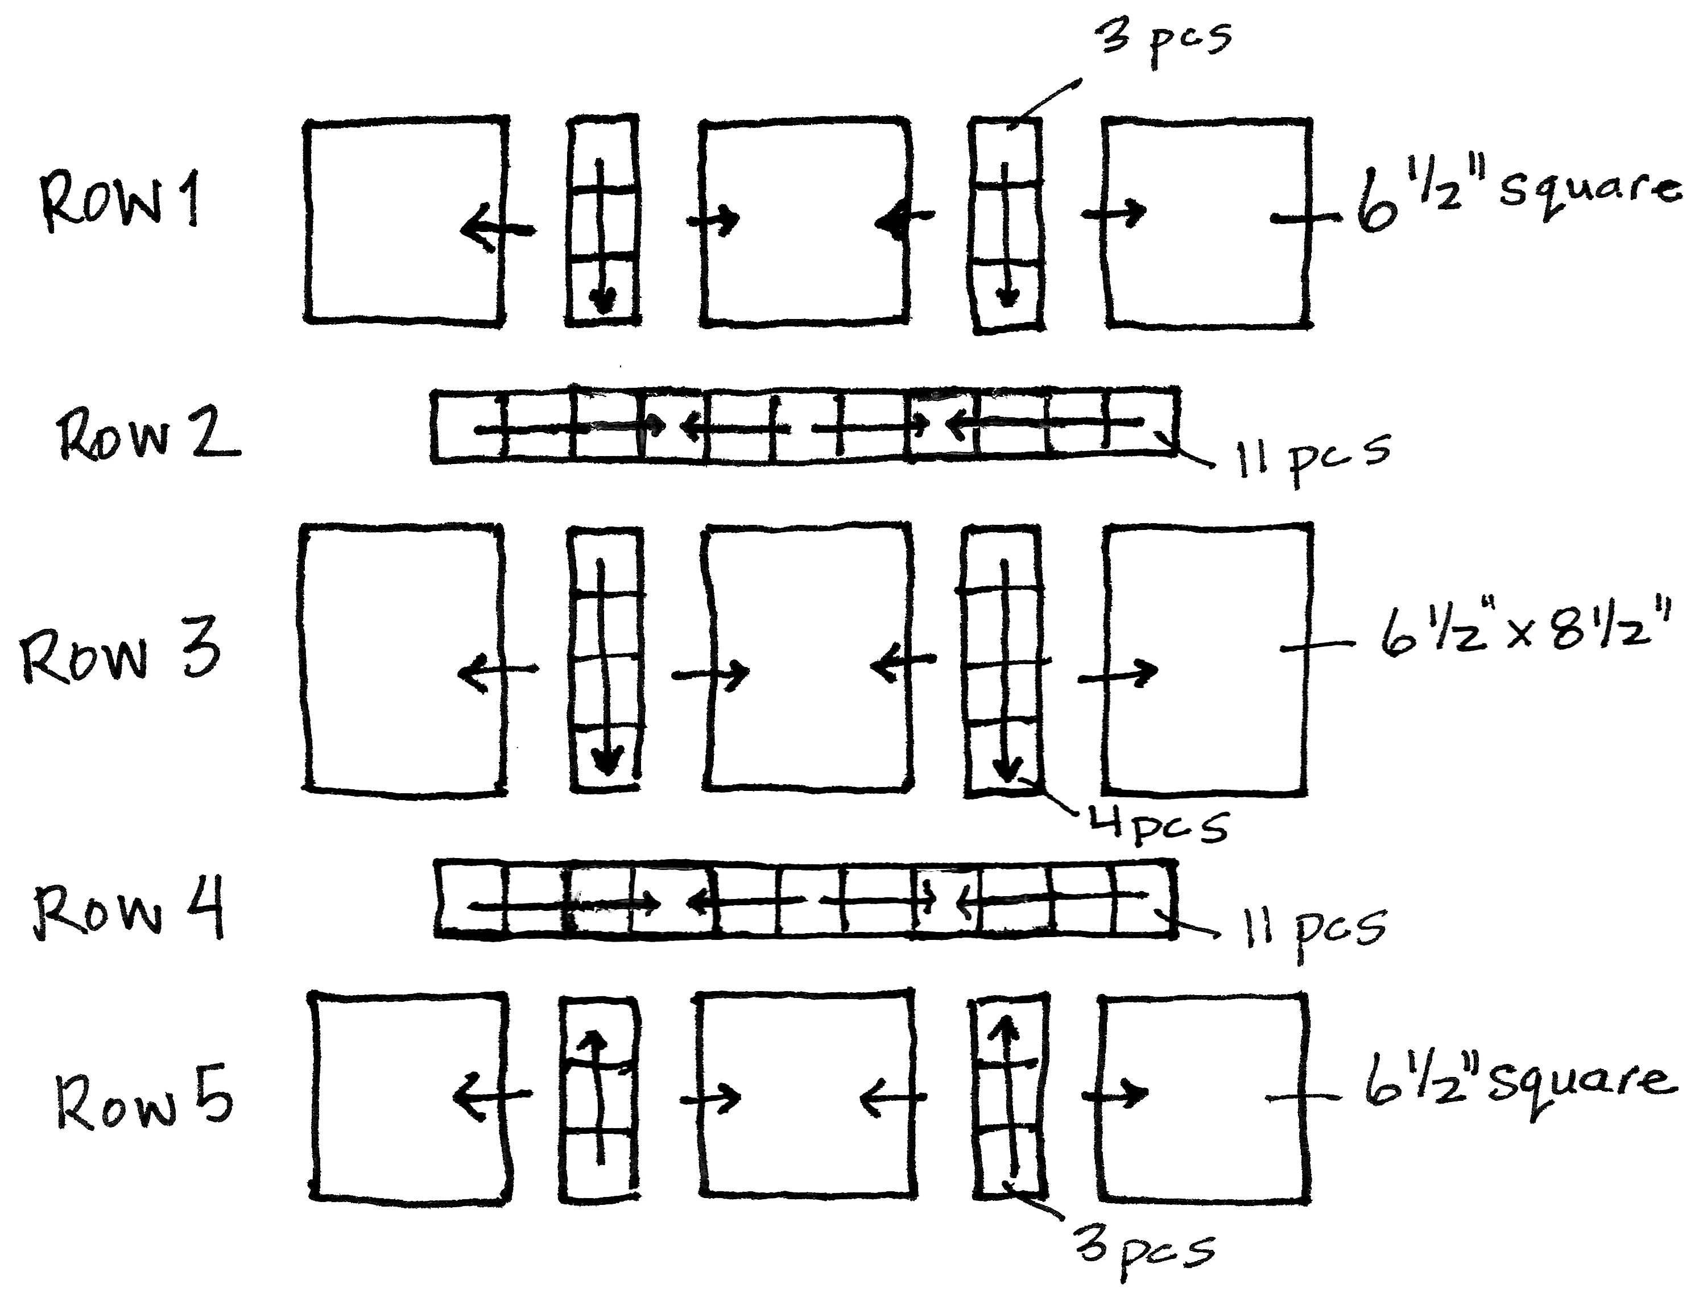
Lay out the quilt before sewing together so you can place the 2-1/2” squares mini charms in a visually pleasing arrangement. Follow the diagram for layout.

Following the diagram, sew the mini charm segments together (four 3-piece segments, two 4-piece segments, and two 11-piece segments). Press seam allowances in the directions of the arrows (generally toward the background or toward the intersecting mini charm squares).

Sew segments and background pieces into rows. Sew rows together, butting seams allowances where they meet. Press seam allowances away from mini charm segments. Sew the side borders on, then press seam allowance toward the border. Repeat with top and bottom borders, backstitching these seams to prevent unraveling during quilting.

Quilt as desired and bind. Enjoy!

